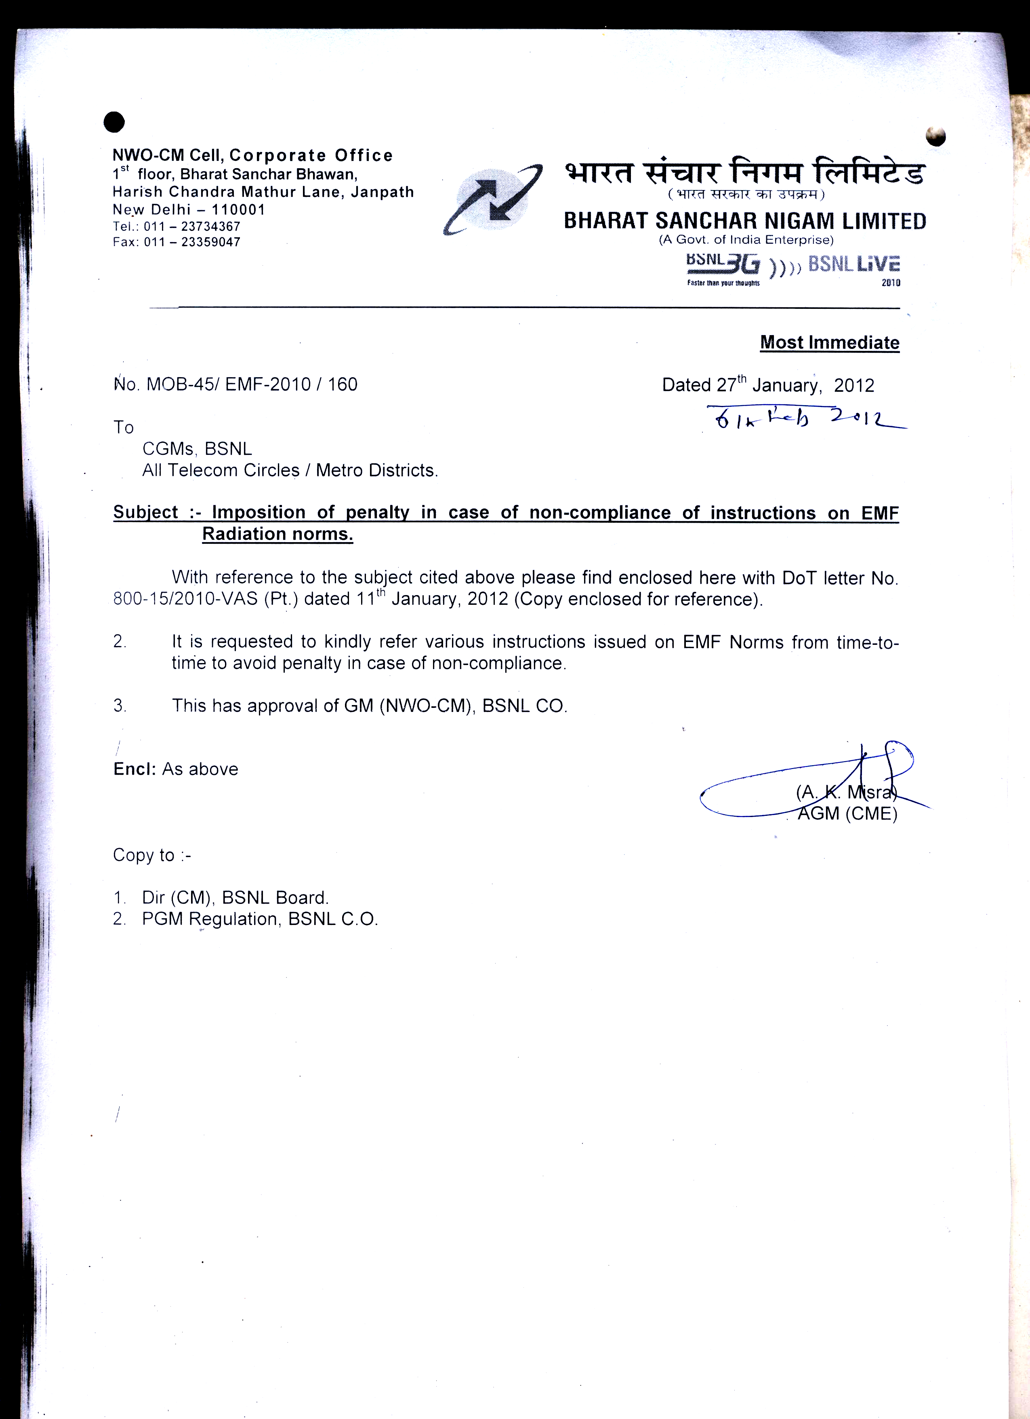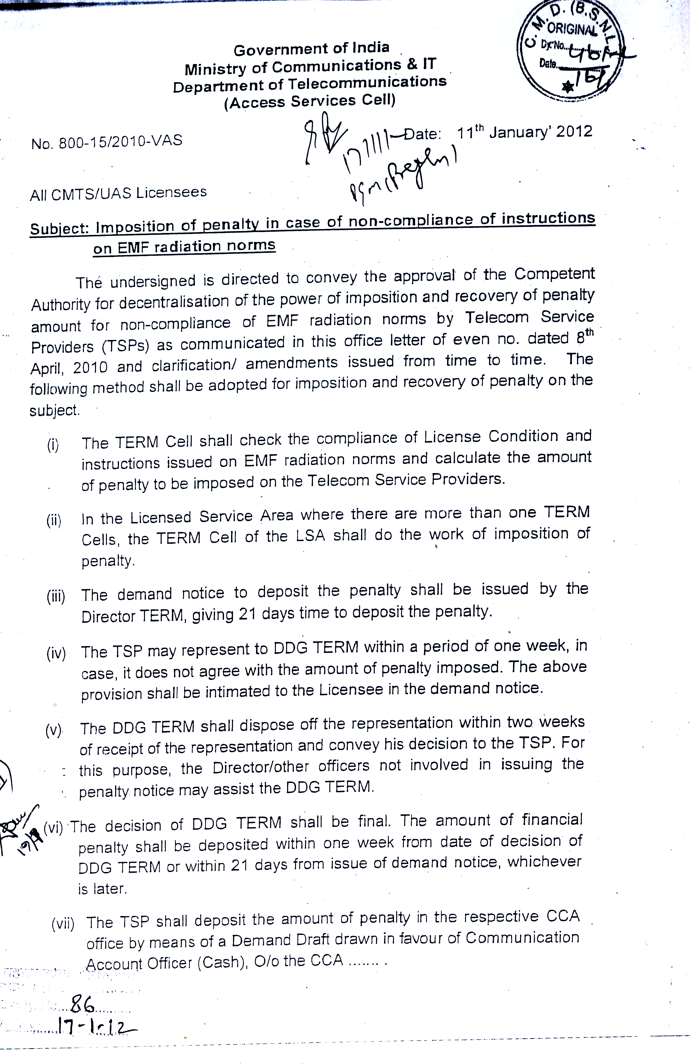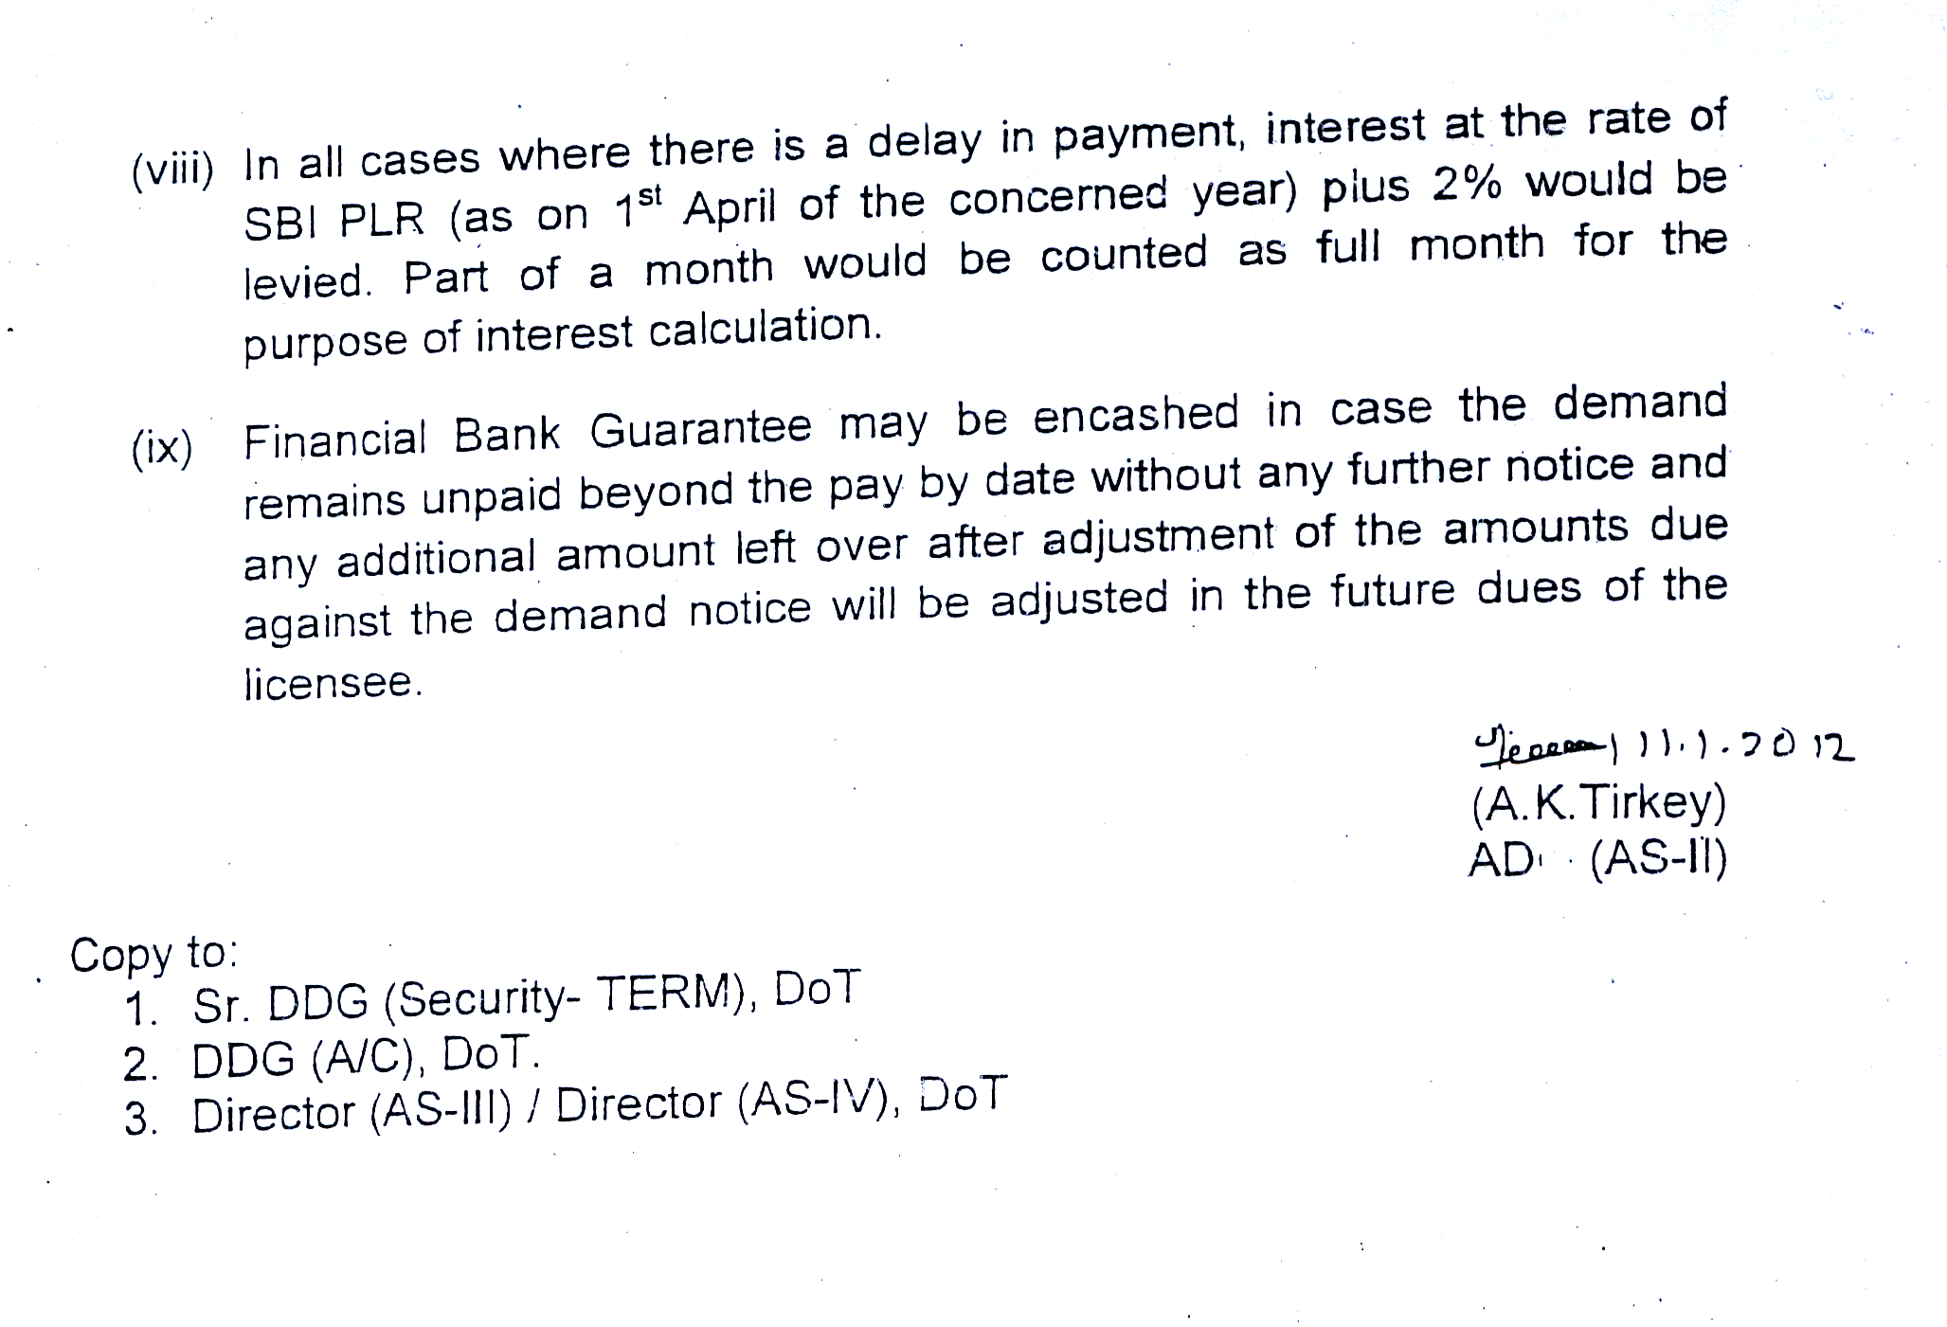

NWO-CM Cell, Corporate Office

1st floor, Bharat Sanchar Bhawan,
Harish Chandra Mathur Lane, Janpath

New Delhi – 110001
Tel.: 011 – 23734367
Fax: 011 – 23359047
 _________________________________________________________________________

Most Immediate

No. MOB-45/ EMF-2010 / 159 Dated February 6, 2012

To
CGMs, BSNL
All Telecom Circles / Metro Districts.

Subject :- EMF Radiation by Base Transceiver Stations (BTSs).

With reference to the subject cited above please find enclosed here with DoT letter No. 800-15/2010-VAS (Pt.) dated 21st December, 2011 (Copy enclosed for reference).

- It is requested to kindly ensure that the frequency of self certification for the BTS/sites shall be after every two years in place of every year, in line with above referred letter. Accordingly, the date of submitting the self certification for next two year cycle shall end on 31.03.2013.

- This has approval of GM (NWO-CM), BSNL CO.

Encl: As above Sd/-
(A. K. Misra)
AGM (CME)
BSNL C.O.
Copy to :-

- Dir (CM), BSNL Board.
- PGM Regulation, BSNL C.O.
- Sr. GMs/GMs (NWO-CM), all Telecom Circles / Metro Districts- for n. a. please as per new norms.

